Can you use junk modelling to create a 3D map of a place that is special to you?  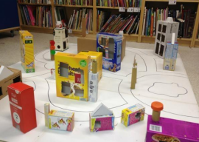 | 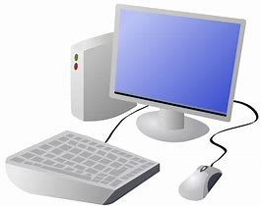  Explore the Ordnance Survey Mapzone.  You’ll find games and quizzes that will help with your map skills.  https://www.ordnancesurvey.co.uk/mapzone/ | 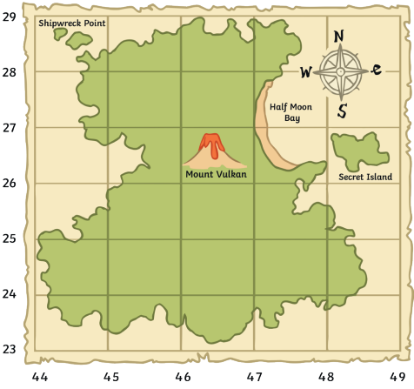  Can you design and make your own treasure map?
Why not have a game of Battle Ships to practise using grid references?  Search ‘battleships’ in Google and ask an adult to help you find a suitable online version.  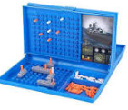 | Acer Class Geography  Home projects  Autumn Term 1  Can you try one or more of these family projects during the term? Please bring your learning into school to show us! | Set up a simple obstacle course then use directional language to direct someone at home through the course. For an extra challenge, blindfold them! (be careful)  